In an Emergency
TAKE ACTION

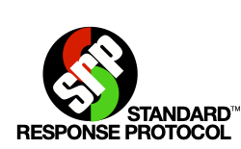
HOLD | SECURE | LOCKDOWN | EVACUATE | SHELTER
Standard Response Protocol – Public Address

Medical  Emergency | Hold in your Room or Area. Clear the halls.
Threat Outside | Secure! Get inside. Lock outside doors.
Threat Inside | Lockdown! Locks, Lights, Out of Sight!
Bomb | Evacuate to (location) Shelter for Bomb!
Earthquake | Shelter for Earthquake!
Fire Inside | Evacuate to the (location)
Hazmat | Shelter for Hazmat! Seal your Rooms
Weapon | Lockdown! Locks, Lights, Out of Sight!
Tornado | Evacuate to (location) Shelter for Tornado!

